LAB TASK QUESTION 1:

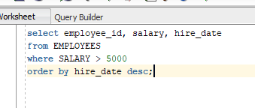

LAB TASK QUESTION 2:

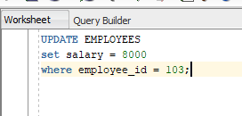

LAB TASK QUESTION 3:

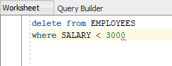

LAB TASK QUESTION 4:

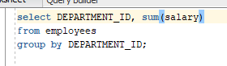

LAB TASK QUESTION 5:

